**FORMAN CHRISTIAN COLLEGE**

**(A CHARTERED UNIVERSITY)**

**CSCS 495 A**

**FA24**

**Installation & Configuration of NESSUS and VEIL**

**Assignment 2 Report**

Daim Bin Khalid – 251686775

4th November, 2024

**Task 1**

Install & Sign-in to Nessus:

Get metasplotiable 2 IP:



Start Basic Network Scan:

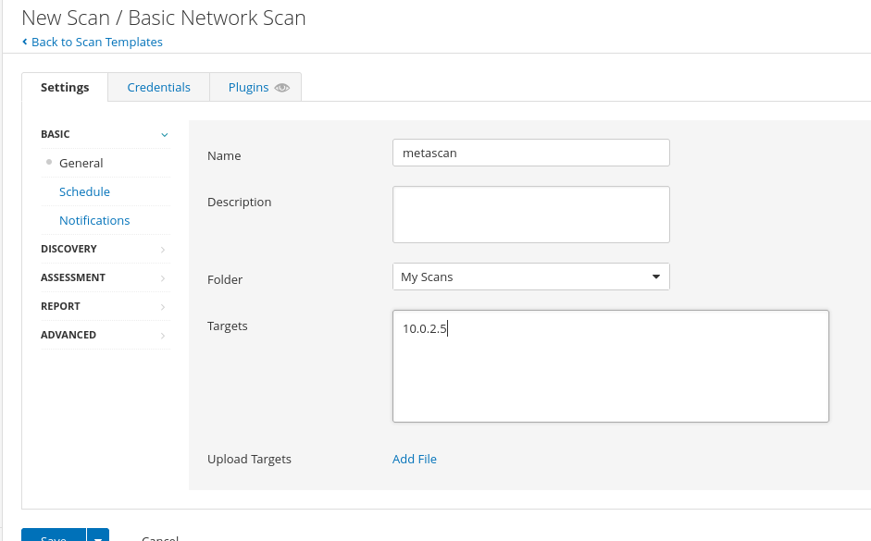

Results:

69 vulnerabilities detected with the following levels:

10 are critical

7 are high

25 are medium

9 are low

134 are just information

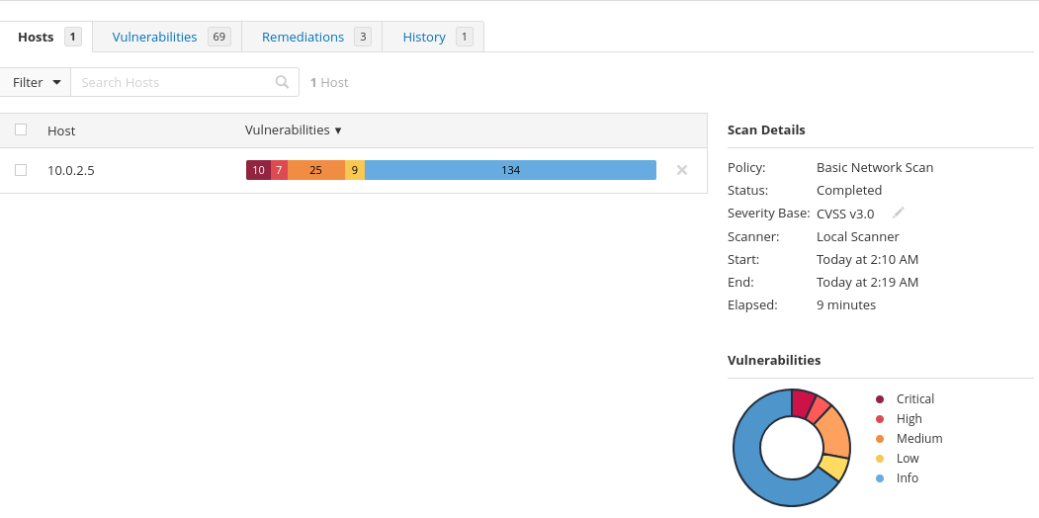

CVSS: 8.6

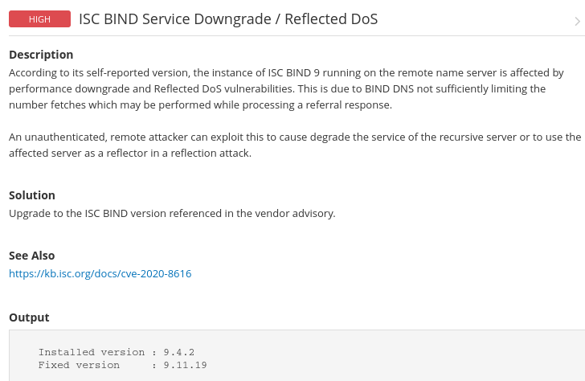

CVSS: 6.5

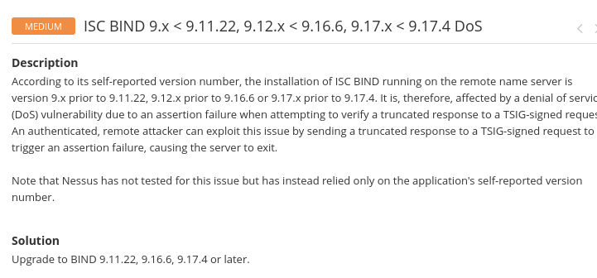

Remediations:

Generated Report:

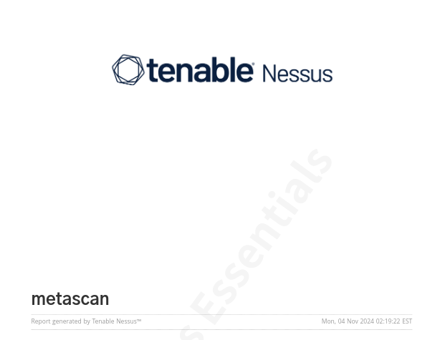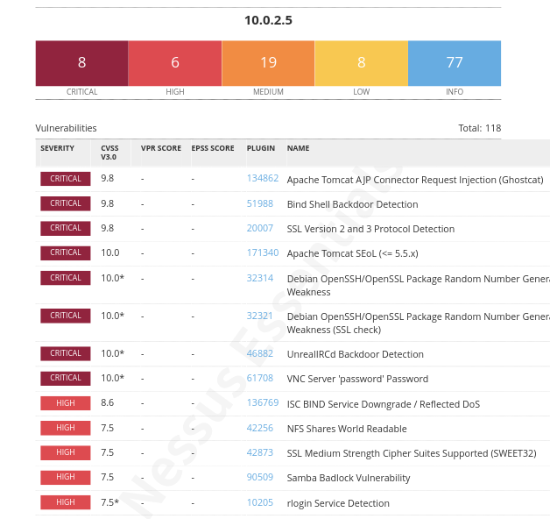

Reflection:

Vulnerability scanning is a very essential component in today’s world. With everything being digitized it is necessary to maintain a certain level of security with the need to increase as the information is more critical, such as organizations. It is important to run vulnerability scans from time to time on our systems to make sure we can amend the loopholes before they become exposed to outside attackers or information leaks. As noticed by the scan report most of the vulnerabilities were information exposure and outdated software that were critical.

**Task 2**

Install & start veil

